**SMART MIRROR**

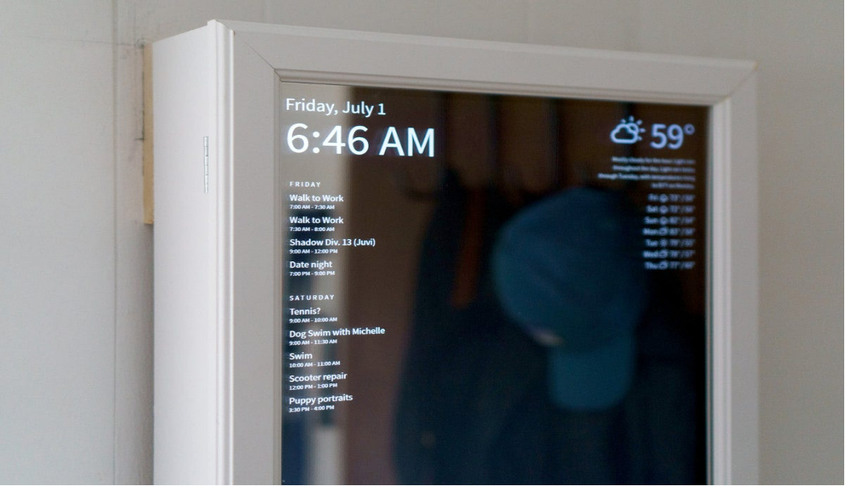

**Problem Statement:**

Many individuals find it challenging to stay organized and informed while getting ready in the morning. Traditional mirrors lack the ability to provide real-time information, such as weather forecasts, news updates, and calendar reminders, which can be valuable for planning the day ahead. Additionally, users may struggle to access smart home controls and health tracking features while in the bathroom or dressing area. There is a need for a solution that integrates these functionalities into a single device, such as a smart mirror, to enhance the grooming experience and streamline daily routines.

**Abstract:**

**A Review of Advancements, Applications, and Future Prospects**

Smart mirrors, also known as magic mirrors or intelligent mirrors, have emerged as innovative devices integrating traditional reflective surfaces with modern digital technology. This paper presents a comprehensive abstract examining the advancements, applications, and prospects of smart mirrors.

Introduction:

The Smart Mirror project aims to address the challenges faced by individuals during their morning routines by developing a smart mirror system that integrates IoT technology and AI capabilities. This project seeks to revolutionize traditional mirrors by incorporating cutting-edge technology to enhance user experience and functionality. The following document provides a comprehensive overview of the design, development, and implementation of a Smart Mirror prototype.

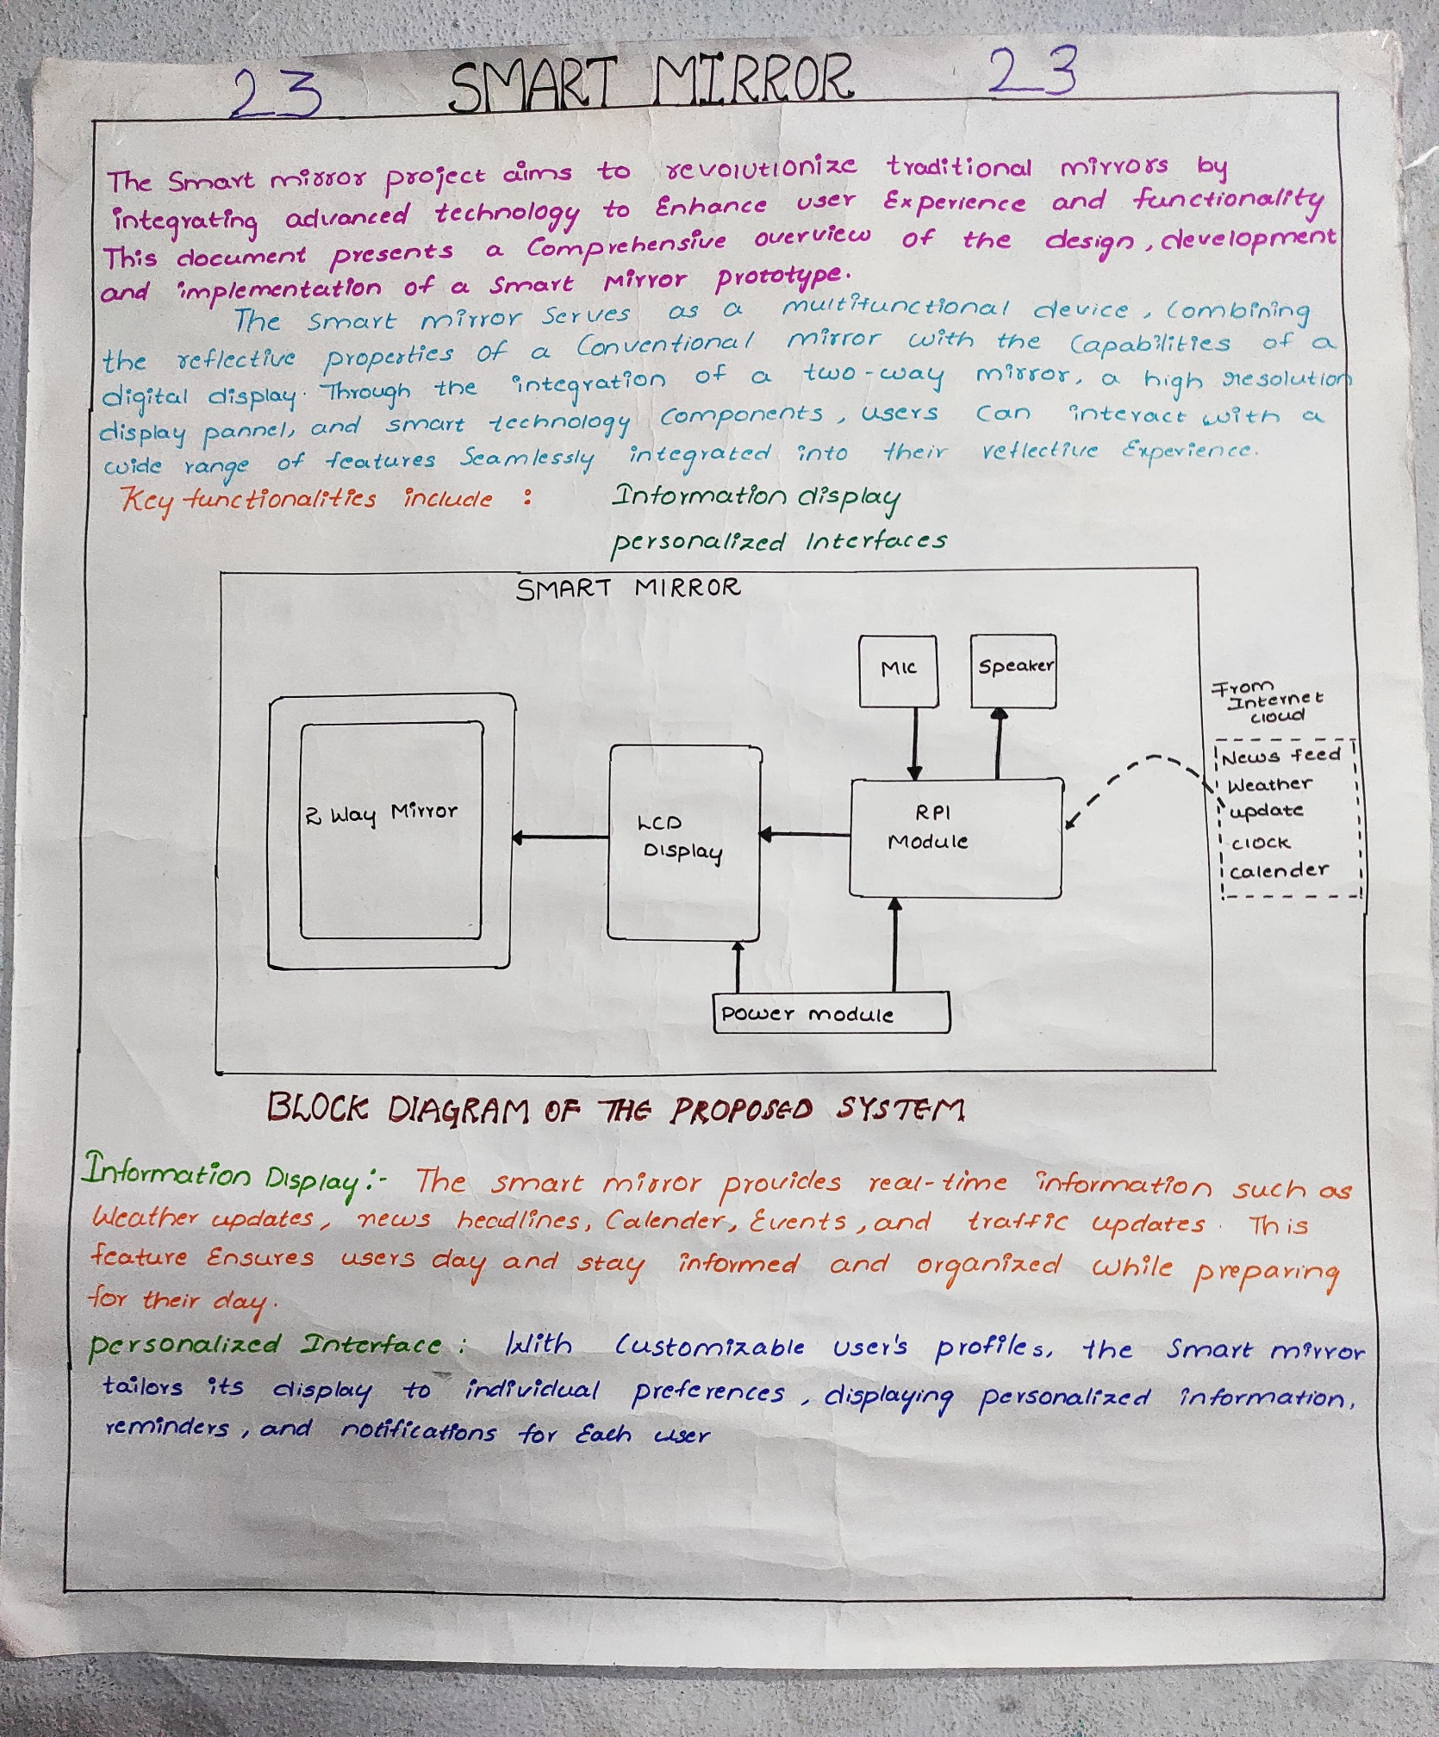

**Materials used:**

* Raspberry Pi 3b
* Raspberry Pi case
* Suitable Raspberry Pi power supply
* MicroSD card
* Adapter to connect microSD card with a computer.
* HDMI USB-C-powered monitor
* USB-C power supply for the display
* Mini HDMI male to standard HDMI cable
* 3mm thick two-way acrylic mirror sheet
* Mirror framing
* Keyboard and mouse

The Smart Mirror project utilizes a Raspberry Pi connected to a monitor, all mounted behind a specially manufactured piece of pre-cut acrylic mirror. This setup allows the display to be visible while retaining the reflective properties of a standard mirror. The hardware components and materials required for the project are listed above.

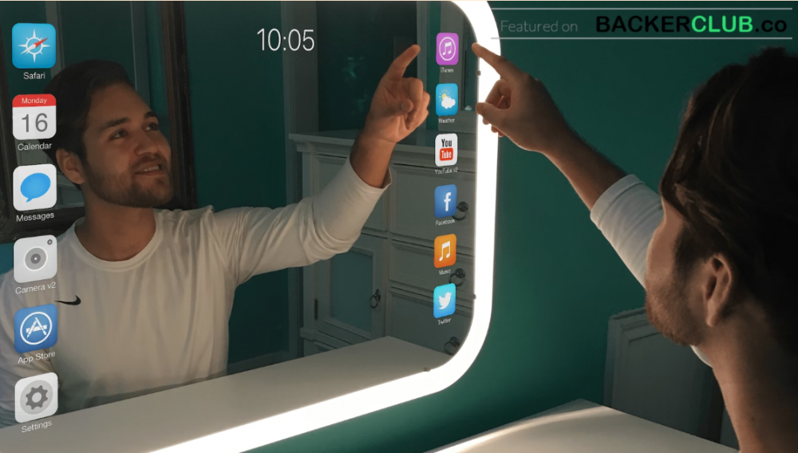

**Key functionalities include:**

1. **Interactive Display:** The mirror functions as a touchscreen display, enabling users to interact with various applications and services.
2. **Personalized Information:** Integration with calendars, weather forecasts, news updates, and other personalized information to provide relevant content to users.
3. **Voice Control:** Incorporating voice recognition technology such as Amazon Alexa or Google Assistant for hands-free operation and interaction.
4. **Facial Recognition:** Ability to recognize different users and provide customized information, such as displaying individual calendars or preferences.
5. **Fitness and Health Tracking:** Integration with fitness trackers or health monitoring devices to display metrics like step count, heart rate, or calorie intake.
6. **Home Automation Integration**: Control smart home devices such as lights, thermostats, or security cameras directly from the mirror interface.
7. **Entertainment:** Access to streaming services, music playback, or video calls for entertainment and communication purposes.
8. **Customizable Widgets**: Allow users to add or remove widgets and applications according to their preferences and needs.

**Applications:**

The applications of the smart mirror vary depending on the modules selected. They have applicability across various fields, including:

* Retail and Fashion: Displaying various brands and drawing customers' attention in supermarkets.
* Home and Personal Use: Programming the smart mirror according to users' preferences, contributing to smart home functionality.
* Hospitality and Tourism: Offering personalized welcome messages, local attraction recommendations, hotel amenities, and in-room dining orders in hotels.
* Education and Training: Enhancing interactive learning experiences, displaying educational content, facilitating presentations, and engaging classrooms in educational institutions.

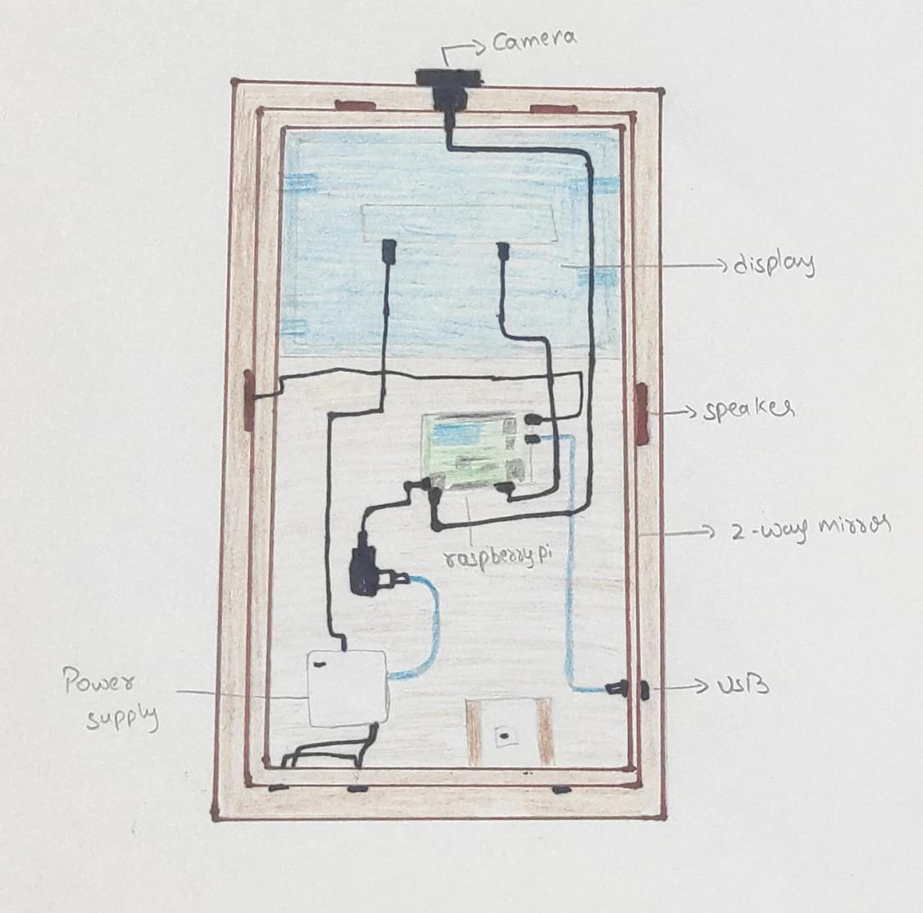

**Participants:**

* HARSHA VENKAT IMADABATHUNI
* POOJITHA JAMMULA
* GOWRI SHANKAR KATTA
* BHASKAR BATTULA